Практическая работа №17
Задание 1.
def get_days(month):
days_in_month = [31, 28, 31, 30, 31, 30, 31, 31, 30, 31, 30, 31]
return days_in_month[month - 1]

print(get_days(1))
print(get_days(2))
print(get_days(9))

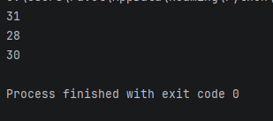

Задание 2.
def is_prime(num):
if num < 2:
return False

for i in range(2, int(num ** 0.5) + 1):
if num % i == 0:
return False

return True

print(is_prime(1))
print(is_prime(10))
print(is_prime(17))

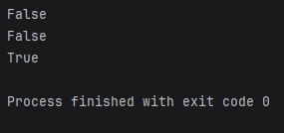

Задание 3.
def is_prime(num):
if num < 2:
return False
for i in range(2, int(num ** 0.5) + 1):
if num % i == 0:
return False
return True

def get_next_prime(num):
next_num = num + 1

while not is_prime(next_num):
next_num += 1

return next_num

print(get_next_prime(6))
print(get_next_prime(7))
print(get_next_prime(14))

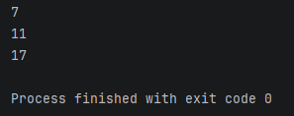

Задание 4.
def is_password_good(password):

if len(password) < 8:
return False

has_upper = False
has_lower = False
has_digit = False

for char in password:
if char.isupper():
has_upper = True
elif char.islower():
has_lower = True
elif char.isdigit():
has_digit = True

return has_upper and has_lower and has_digit

print(is_password_good('aabbCC11OP'))
print(is_password_good('abC1pu'))
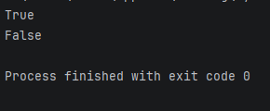

Задание 5.
def is_palindrome(n):
s = str(n)
return s == s[::-1]

def is_prime(n):
if n < 2:
return False
for i in range(2, int(n ** 0.5) + 1):
if n % i == 0:
return False
return True

def is_valid_password(password):
parts = password.split(':')
if len(parts) != 3:
return False

a_str, b_str, c_str = parts

if not (a_str.isdigit() and b_str.isdigit() and c_str.isdigit()):
return False

a, b, c = int(a_str), int(b_str), int(c_str)

if a <= 0 or b <= 0 or c <= 0:
return False

return is_palindrome(a) and is_prime(b) and (c % 2 == 0)

print(is_valid_password('1221:101:22'))
print(is_valid_password('565:30:50'))
print(is_valid_password('112:7:9'))
print(is_valid_password('1221:101:22:22'))

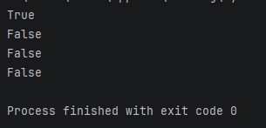

Задание 6.
def solve(a, b, c):

d = b ** 2 - 4 * a * c

if d == 0:
root = -b / (2 * a)
return root, root

sqrt_d = d ** 0.5

if b >= 0:
x1 = (-b - sqrt_d) / (2 * a)
x2 = (2 * c) / (-b - sqrt_d)
else:
x1 = (2 * c) / (-b + sqrt_d)
x2 = (-b + sqrt_d) / (2 * a)

return min(x1, x2), max(x1, x2)

print(solve(1, -4, -5)) # (-1.0, 5.0)
print(solve(-2, 7, -5)) # (1.0, 2.5)
print(solve(1, 2, 1)) # (-1.0, -1.0)

